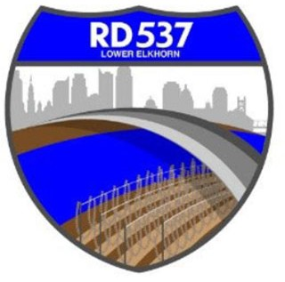
NOTICE OF MEETING AND AGENDA RECLAMATION DISTRICT NO. 537

The Board of Trustees of Reclamation District No. 537 has called a regular board meeting to be held at 9:00 a.m. on Tuesday, April 7, 2026. This meeting is open to the public. Members of the public may attend this meeting in person at 889 Drever Street, West Sacramento, CA 95691 or participate remotely, using the following information:
- Online, via Microsoft Teams at https://teams.microsoft.com/meet/24617053147541?p=OwgXPlN5eYvshmggar
- By phone, at 1-916-538-7032; Conference ID: 262 365 353#

During this period of modified Brown Act requirements, RD 537 will use best efforts to swiftly resolve requests for reasonable modifications or accommodations with individuals with disabilities, consistent with the Americans with Disabilities Act, and resolving any doubt whatsoever in favor of accessibility. If you need a disability related modification or accommodation to participate in this meeting, then please call Billy Mattos at (916) 531-1199 or rd537elkhorn@gmail.com. Requests must be made as early as possible, and at least one full business day before the start of the meeting.

AGENDA
Call to Order
- Meeting attendance/introductions
- Approval of agenda
- Approval of minutes from February 3, 2026 Board Meeting

Public Comment on Non-Agenda Items

Business/Action Items
- Report on District Finances
  - Balance Sheet
  - Status of District finances
- I-5 Erosion
- Old Fire Department Lease
- Corp Yard
  - Financial Update
  - CAMU Updates
      - Forgen – Erosion
      - S&S Fence - Change Order
      - Hoot System Contract
      - Office Building
      - Electrical
      - Other
- Engineers’ Report and Updates (MBK):
  - RD 537/DWR Land Management Contract
  - MBK Contract
- Attorneys’ Report
  - Request for Waiver – RD 1000 Property Acquisition

Informational Items
- Manager’s Report
- YSGA Update
- Additional Informational Items/Trustee Comments
- Adjourn

Closed Session
N/A

