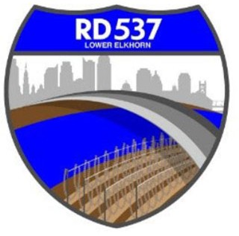NOTICE OF MEETING AND AGENDA RECLAMATION DISTRICT NO. 537

The Board of Trustees of Reclamation District No. 537 has called a regular board meeting to be held at **9:00 a.m.** on **Tuesday,** **August 1, 2023**. This meeting is open to the public. Members of the public may attend this meeting in person at 889 Drever Street, West Sacramento, CA 95691 or participate remotely, using the following information:

* Online, via Microsoft Teams at bit.ly/43clHS1
* By phone, at 1-916-538-7032; Conference ID: 84789295

During this period of modified Brown Act requirements, RD 537 will use best efforts to swiftly resolve requests for reasonable modifications or accommodations with individuals with disabilities, consistent with the Americans with Disabilities Act, and resolving any doubt whatsoever in favor of accessibility. If you need a disability related modification or accommodation to participate in this meeting, then please call Billy Mattos at (916) 531-1199 or [elkhornrd@gmail.com.](mailto:elkhornrd@gmail.com) Requests must be made as early as possible, and at least one full business day before the start of the meeting.

# AGENDA

**Call to Order**

1. Meeting attendance/introductions
2. Approval of agenda
3. Approval of minutes of the Board Meetings from June 6

# Public Comment on Non-Agenda Items District

# Business/Action Items

1. Report on District Finances
   1. Status of District finances
   2. Checks & Claims
   3. Wire Transfers
   4. Bank Reconciliations
   5. Balance Sheet
   6. Tractor balance and payment
2. Engineers’ Report and Updates (MBK):
   1. DWR Spring Inspection
   2. FMAP Update
      1. CEQA Resolution Exempting 2023-2024 Routine Maintenance
      2. FMAP attachment B – Resolution authorizing LMA funding proposal
      3. Attachment C – Attorney Certification for FMAP funding agreement
   3. FEMA Update
   4. Pump Station Update
   5. Yolo Bypass Levee Update
   6. CAMU Update
      1. Review and approve Geosyntec Contract Amendment
   7. Upper Elkhorn Feasibility Study
3. USACE Weir Widening Project Update
4. Attorneys’ Report

# Informational Items

1. Manager’s Report
2. WSAFCA Update
3. Additional Informational Items/Trustee Comments
4. Adjourn