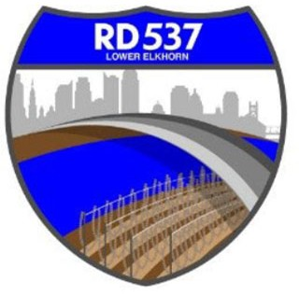
NOTICE OF MEETING AND AGENDA RECLAMATION DISTRICT NO. 537

The Board of Trustees of Reclamation District No. 537 has called a regular board meeting to be held at 9:00 a.m. on Tuesday, August 4, 2026. This meeting is open to the public. Members of the public may attend this meeting in person at 889 Drever Street, West Sacramento, CA 95691 or participate remotely, using the following information:
- Online, via Microsoft Teams at https://teams.microsoft.com/meet/24617053147541?p=OwgXPlN5eYvshmggar
- By phone, at 1-916-538-7032; Conference ID: 262 365 353#

During this period of modified Brown Act requirements, RD 537 will use best efforts to swiftly resolve requests for reasonable modifications or accommodations with individuals with disabilities, consistent with the Americans with Disabilities Act, and resolving any doubt whatsoever in favor of accessibility. If you need a disability related modification or accommodation to participate in this meeting, then please call Billy Mattos at (916) 531-1199 or rd537elkhorn@gmail.com. Requests must be made as early as possible, and at least one full business day before the start of the meeting.

AGENDA
Call to Order
- Meeting attendance/introductions
- Approval of agenda
- Approval of minutes from June 2, 2026 Board Meeting

Public Comment on Non-Agenda Items

Business/Action Items
- Report on District Finances
  - Balance Sheet
  - Status of District finances
  - Audit (status and new auditor)
- I-5 Erosion Update
- Old Fire Department Lease Update
- Gas & Water Well Update
- Corp Yard
  - CAMU Updates
      - Forgen
      - S&S Fence
      - Hoot System
      - Office Building
      - Electrical
      - Other
- Funding Agreement - State of California DWR and RD 537 Lower Elkhorn Basin Levee Setback Long-term Management Planning a part of the Systemwide Flood Risk Reduction Program
- Engineers’ Report and Updates (MBK):
  - Maintenance
- Attorneys’ Report
  - Adopt Resolution declaring the property exempt surplus land.
  - Approve the Purchase and Sale Agreement and authorize execution of all necessary documents.
  - Adopt Resolution accepting the property transfer.
  - Authorize execution and recordation of all documents necessary to complete the transaction.

Informational Items
- Manager’s Report
- YSGA Update
- Additional Informational Items/Trustee Comments
- Adjourn

Closed Session
N/A

