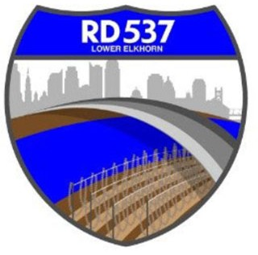NOTICE OF MEETING AND AGENDA RECLAMATION DISTRICT NO. 537

The Board of Trustees of Reclamation District No. 537 has called a regular board meeting to be held at **9:00 a.m.** on **Tuesday, February 7, 2023**. This meeting is open to the public. In compliance with Assembly Bill 361, members of the Board of Trustees and members of the public may participate in this meeting remotely, using the following information:

* Online, via Microsoft Teams at https://bit.ly/3Y3Cbcs
* By phone, at 1-916-538-7032; Conference ID: 431917748#.

During this period of modified Brown Act requirements, RD 537 will use best efforts to swiftly resolve requests for reasonable modifications or accommodations with individuals with disabilities, consistent with the Americans with Disabilities Act, and resolving any doubt whatsoever in favor of accessibility. If you need a disability related modification or accommodation to participate in this meeting, then please call Billy Mattos at (916) 716-3703 or [elkhornrd@gmail.com.](mailto:elkhornrd@gmail.com) Requests must be made as early as possible, and at least one full business day before the start of the meeting.

# AGENDA

**Call to Order**

1. Meeting attendance/introductions
2. Approval of agenda
3. Review and consider findings related to remote meetings pursuant to AB 361
4. Approval of minutes of the Board Meeting on December 6, 2023

# Public Comment on Non-Agenda Items District Business/Action Items

1. Report on District Finances
   1. Status of District finances
   2. Checks & Claims
   3. Wire Transfers
   4. Bank Reconciliations
   5. Balance Sheet
2. Engineers’ Report and Updates (MBK):
   1. Pump Station/Interior Drainage Update
   2. CAMU Update
   3. FMAP Update
3. USACE Weir Widening Project Update
4. FEMA:
   1. Emergency update
   2. CalOES 130 Resolution (Designation of Applicant’s Agent Resolution for Non-State Agencies)
   3. RD 537 Emergency Resolution
5. Attorneys’ Report

# Informational Items

1. Manager’s Report
2. WSAFCA Update
3. Additional Informational Items/Trustee Comments
4. Adjourn

1839235v1 ** Meeting materials will be available to the public at the same time that they are distributed to all or a majority of Board members. To obtain copies of these materials, contact the District by ph:one at (916) 716-3703 or [elkhornrd@gmail.com.](mailto:elkhornrd@gmail.com)